I used this Koha Newbie Guide to get me started, it was super helpful. I would recommend it for anyone who has zero experience with Koha, like me. Whoever wrote it has a sense of humor.
https://wiki.koha-community.org/wiki/Newbie_guide#

Defining new branch library:
Home >> Koha administration >> Basic Parameters >> Libraries>> + New library

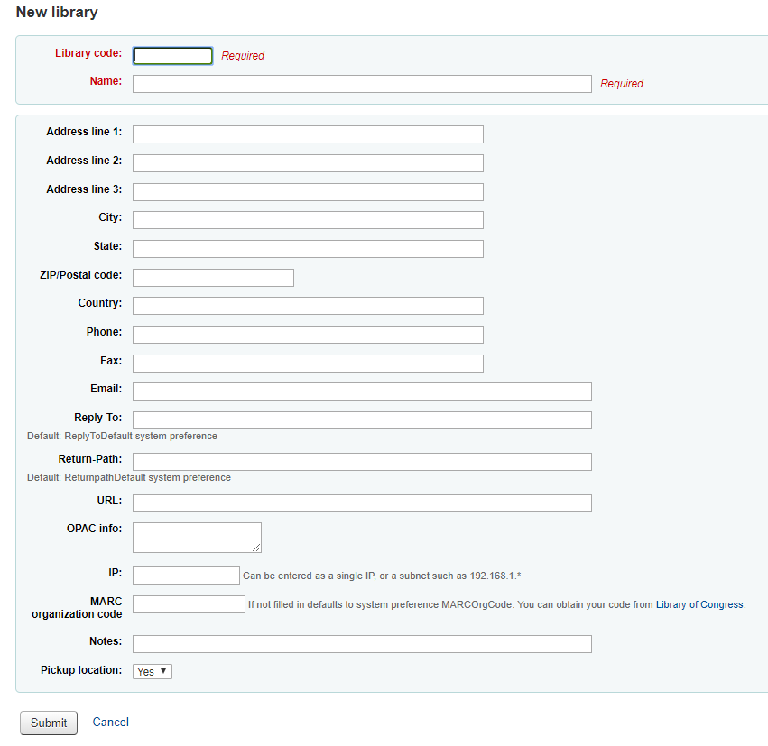

Budgets
Home >> Koha administration >> Acquisition parameters >> Budgets >> + New budget
**Added new book budget**
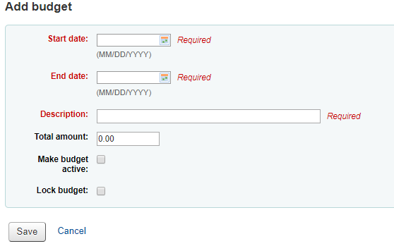
Funds
Budgets >> selected budget >> Actions drop down >> + Add fund
**added COVID-19 Relief fund to book budget**
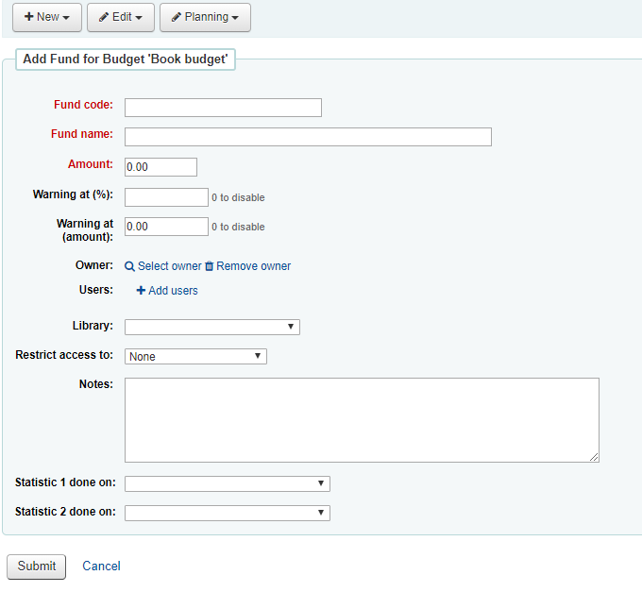

Adding item types
Home >> Koha administration >> Basic Parameters >> Item Types >> + New item type
**added EBOOK item type- limited to Library Group 4**
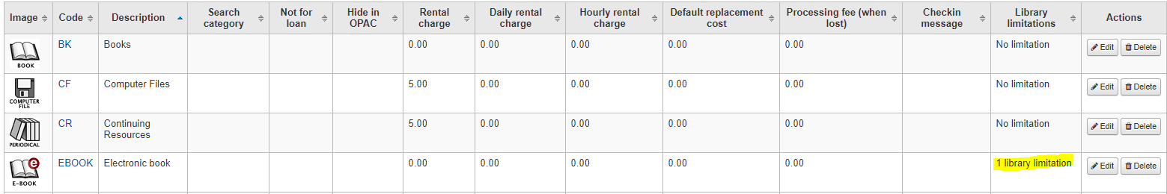
Adding cities
Home >> Koha administration >> Patrons and circulation >> Cities and towns >> + New city
**Added Bookville, NC as new city**
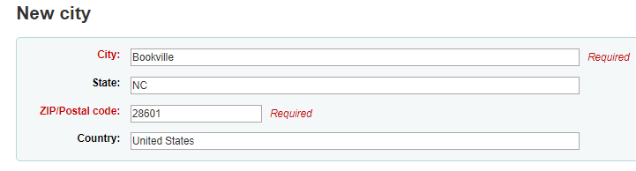

Edit hold policy by patron
Home >> Koha administration >> Patrons and circulation >> Circulation fines and rules
**Restricted total current checkouts, total current on-site checkouts, and total holds allowed for Inter-Library loan category**
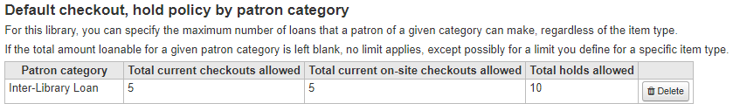

Add Z39.50 servers
Home >> Koha administration >> Additional Parameters >> Z39.50/SRU servers >> + New Z39.50 server
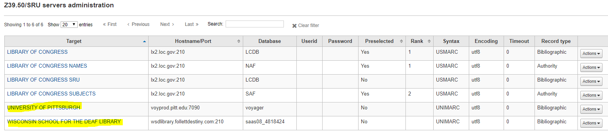

Add MARC record
Home >> Cataloging >> + New record >> Choose framework >> X39.50/SRU search >>Select all search targets >> enter parameters and search >> choose record >> Actions drop down >> Import >> Save
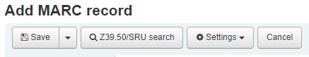
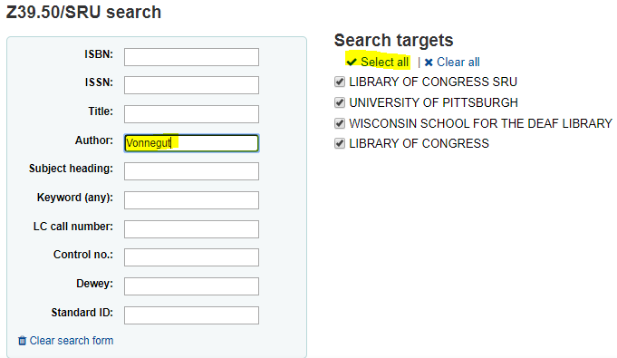

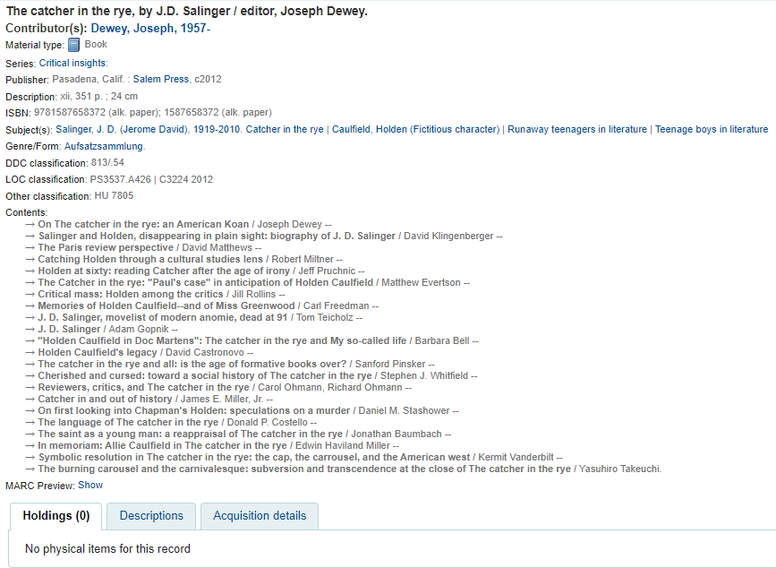

Add staff user
Home >> Patrons >> + New patron drop down >> Staff
**Added three new staff patrons**
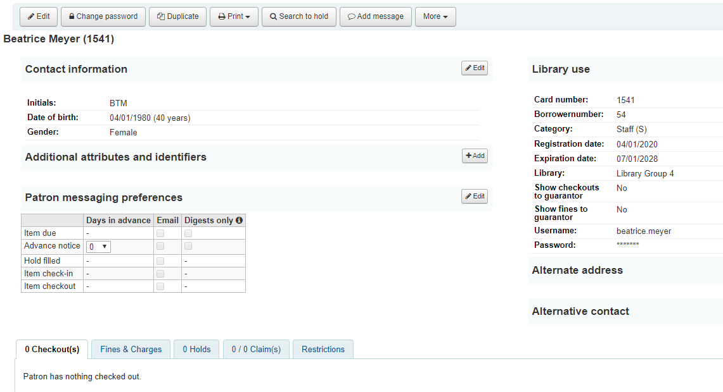

Edit staff user privileges
Home >> Patrons >> Patron details >> More drop down menu >> Set permissions
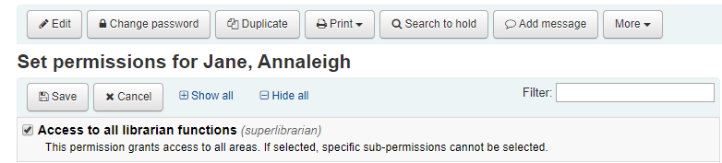

Edit displayed patron information
Home >> Patrons >> Browse by last name >> Gear option with Columns
**Removed DOB and circ note from patron information display**
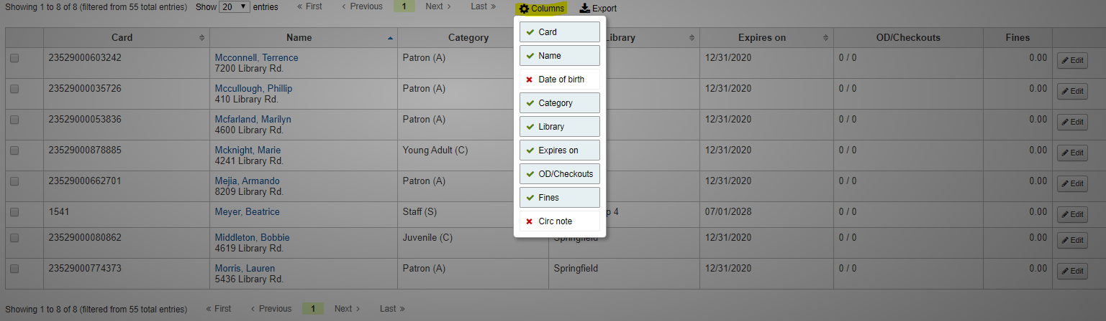

Edit patron messaging preferences
Home >> Patrons >> Patron details >> Patron messaging preferences edit option
**Changed email preferences to alert three days in advance for items due**
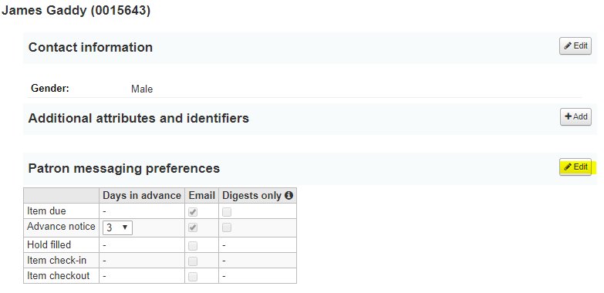
Patrons checking out materials
Home >> Circulation >> Checkouts >> enter patron name and select >> enter item barcode >> check out
**Checked out Sorcery of thorns to patron Bethany Wyrick**

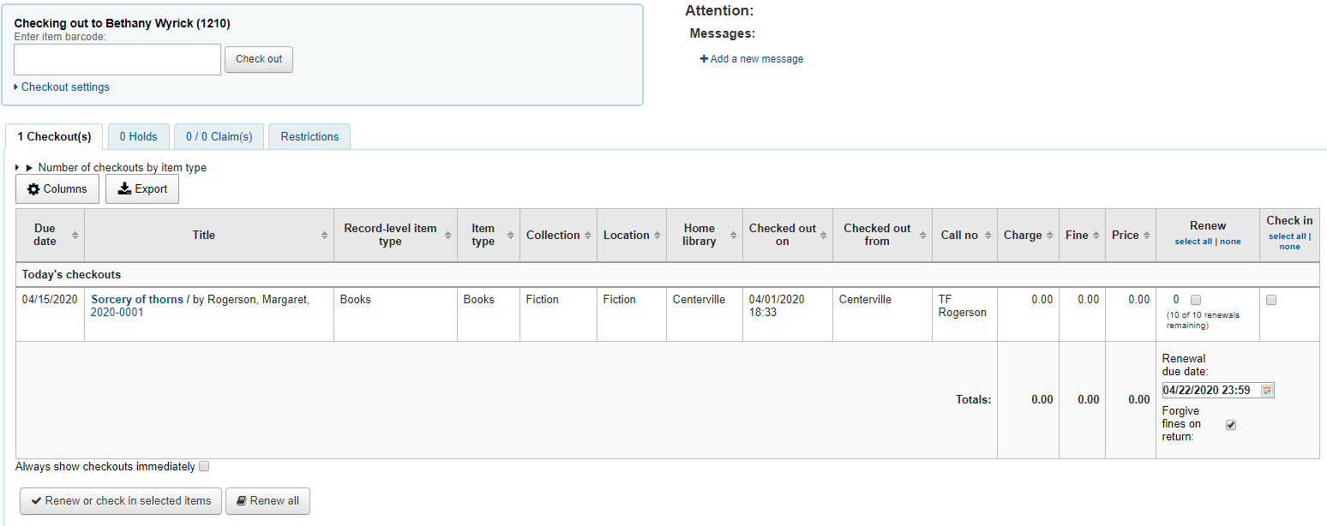

Placing orders for publications
Home >> Acquisitions >> search for vendor >> click on selected basket >> + Add to basket >> From an external source >> key in criteria >> from results, click + Order
**NOTE: I had to edit the global system preferences AcqCreateItem to “Create an item when receiving an order” to be able to change the locked zero quantity when adding items to basket **
**Added two items to basket; if vendor contact info was set up, order could be emailed to ALA**
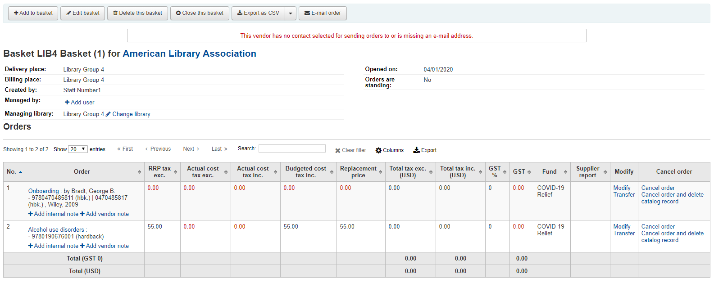
Add Purchase Suggestion
Home >> Acquisitions >> Suggestions >> + New purchase suggestion >> Enter info >> Submit
**Submitted two purchase suggestions**
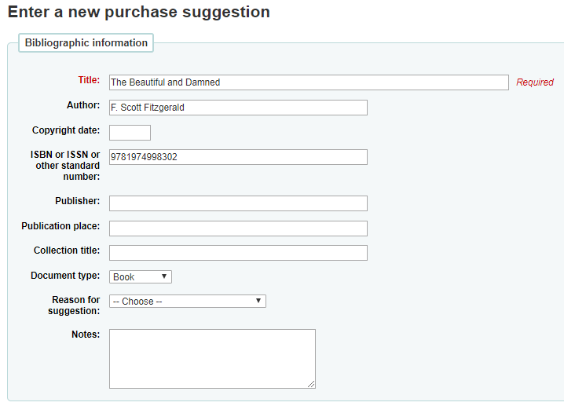

Create Public List of Collection items
Home >> Lists >> Public lists >> + New list
**Added LIB4 public list, also added two items to LIB4 list**
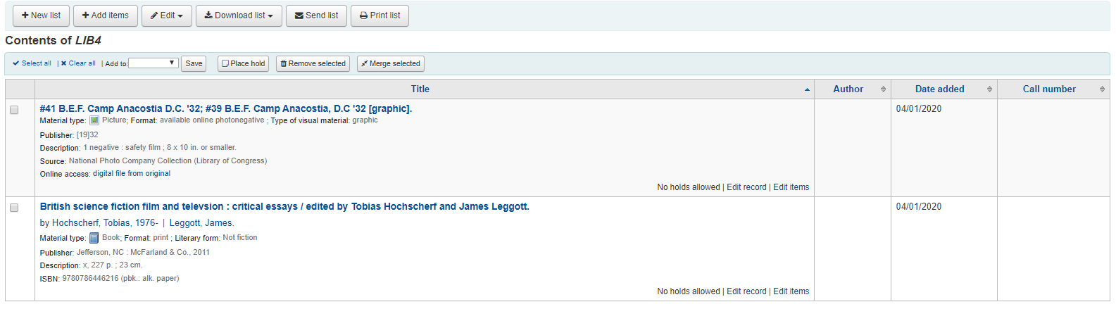
Upload patron images
Home >> Tools >> Patrons and circulation >> Upload patron images >> Choose file to import
**Uploaded profile image to my patron record**
